Assignment 4:

Exploring Instruction-Level Parallelism (ILP) in Modern Processors

Teja Durga Pavan Kumar Ponneboyina
MS in Computer Science
University of Cumberlands

Professor. Dr. Vanessa Ruth Cooper
Course & Term:
2026 Spring - Computer Architecture and Design (MSCS-531-A01) - First Bi-term
Due Date: 2/1/26

Assignment 4:

Exploring Memory Hierarchy Design in gem5
Part 2: Practical Exploration of Instruction-Level Parallelism (ILP) Techniques
Experimental Setup
All experiments in this section were performed using the locally built gem5 X86 simulator on Ubuntu. The simulations were executed in system emulation (SE) mode using the provided se.py configuration script. Although this script is marked as deprecated, it still executes correctly and produces valid statistics.
Simulator binary: build/X86/gem5.opt
Workload used: tests/test-progs/hello/bin/x86/linux/hello
This workload was chosen because it is simple, deterministic, and allows clear observation of instruction behavior without interference from complex application logic.
Cache configuration (used in all runs):
- L1 Instruction Cache: 16 kB
- L1 Data Cache: 64 kB
- Caches enabled using --caches
After every simulation, the generated m5out directory was renamed to preserve results for comparison.
Basic Pipeline Run (Minor CPU)
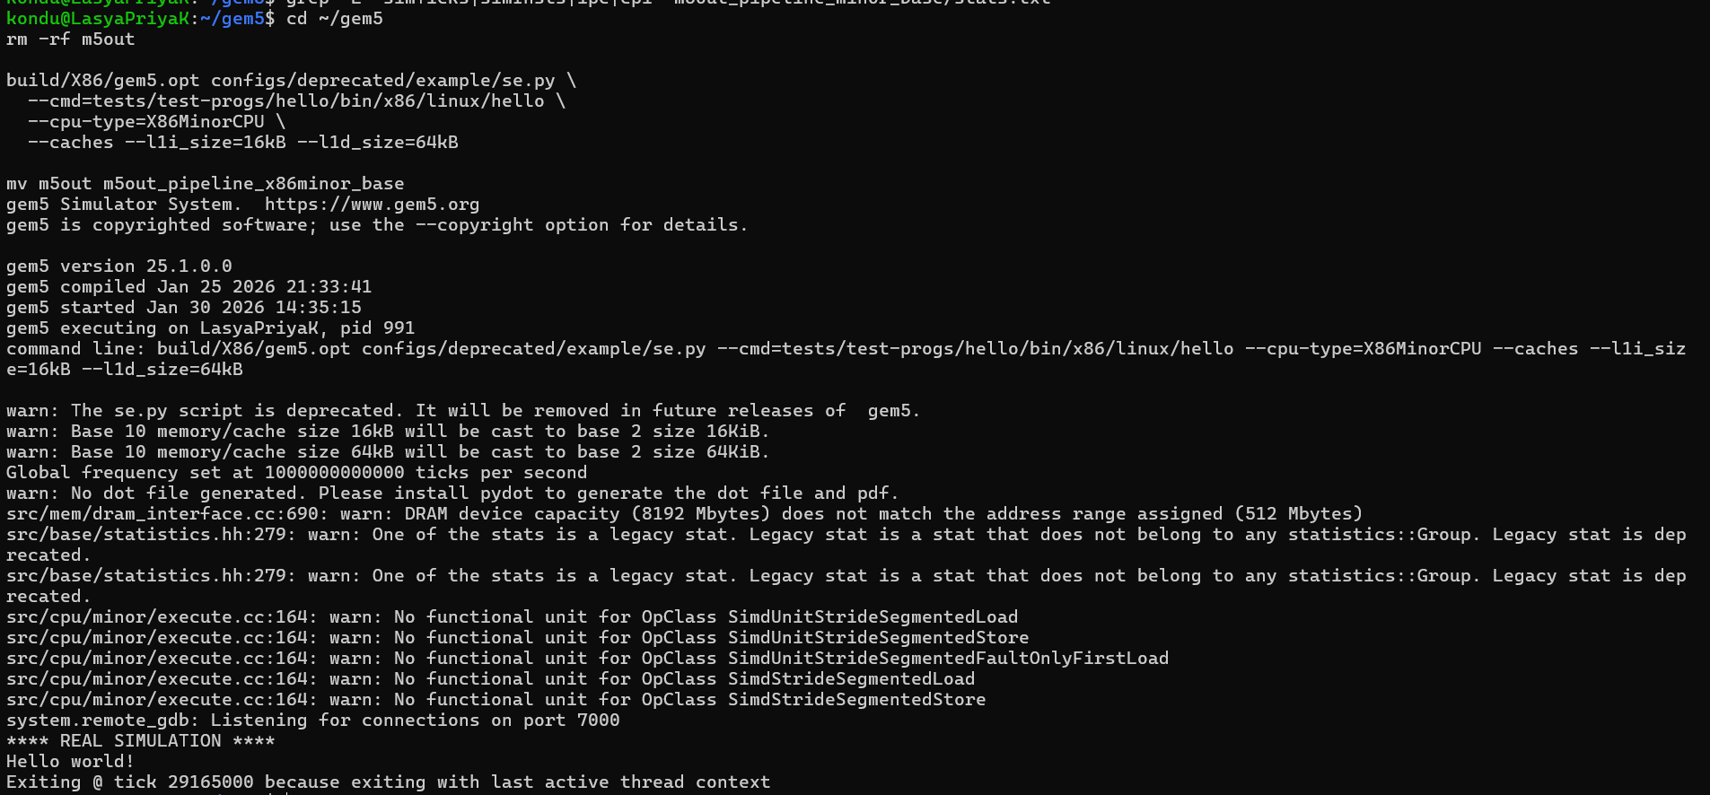
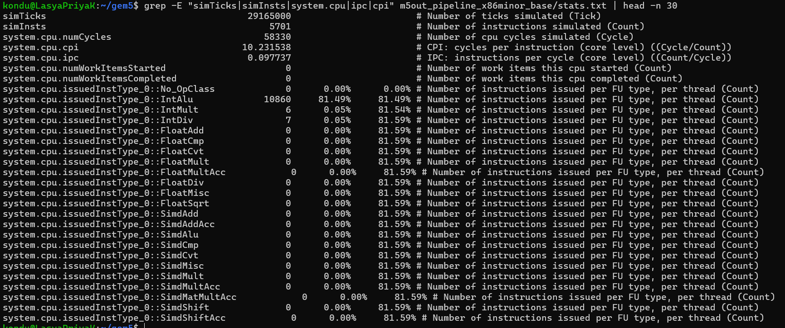
Cycle-by-cycle trace (MinorTrace)
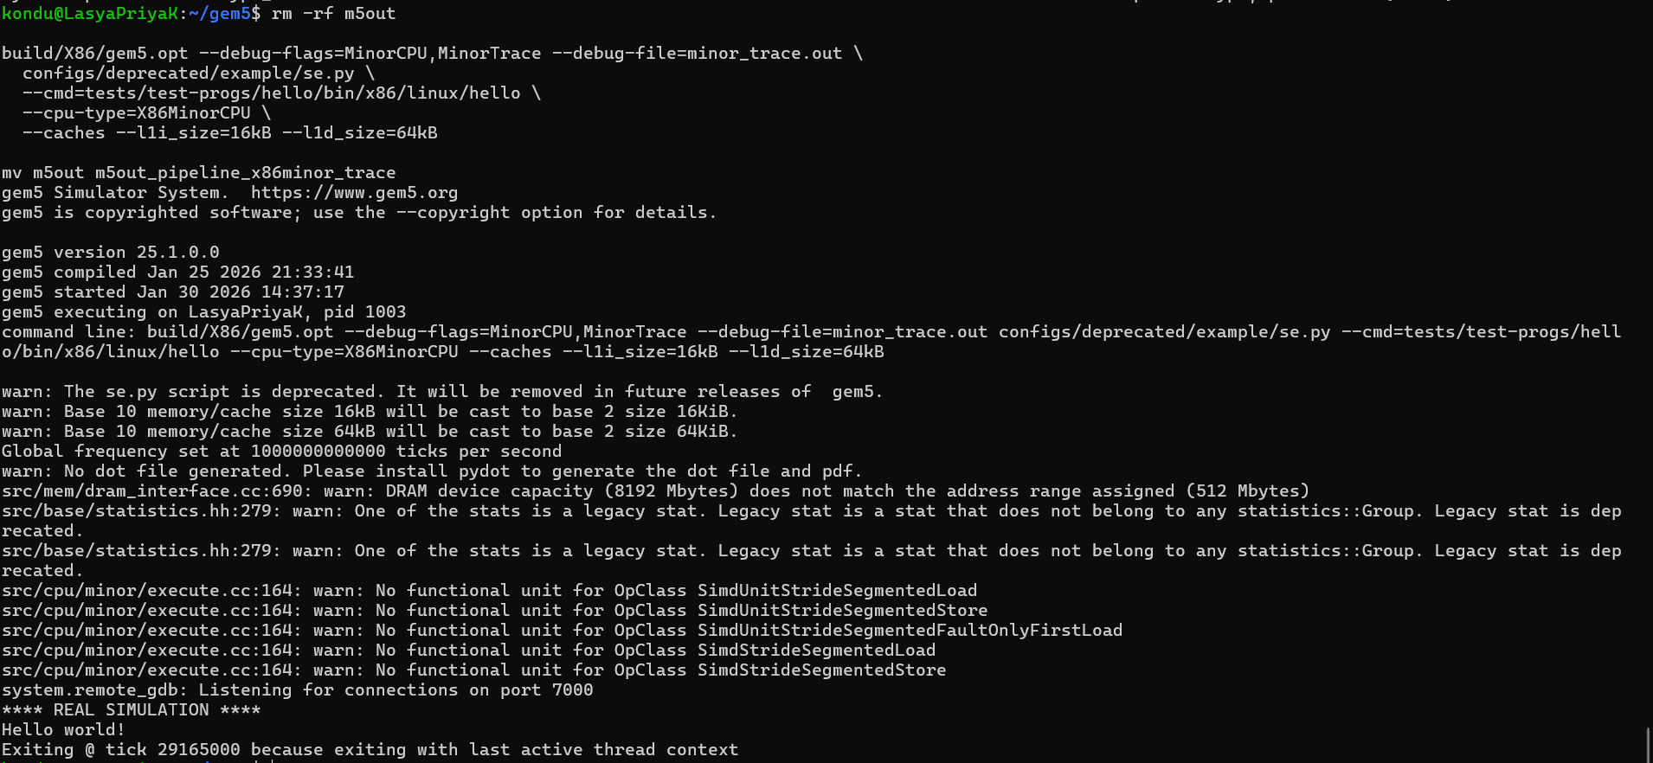
Performance Metrics Collected
The following performance metrics were extracted from m5out/stats.txt for every experiment:
- simTicks – total simulated execution time
- simInsts – number of instructions executed
- IPC (Instructions Per Cycle) – instruction throughput
- CPI (Cycles Per Instruction) – instruction latency
Metrics were extracted using:
grep -E "simTicks|simInsts|system.cpu.ipc|system.cpu.cpi" stats.txt

Branch Prediction Experiment
Objective: To evaluate how branch prediction affects pipeline efficiency and execution time.
Approach: Two runs were compared:
- Default branch prediction configuration
- Fixed branch prediction configuration (confirmed via config.ini)
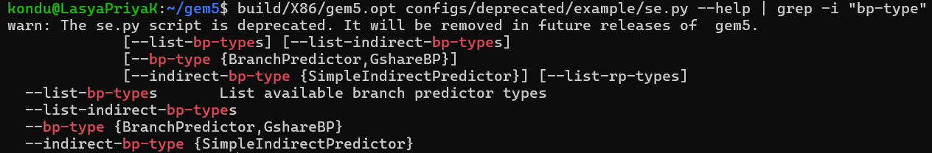
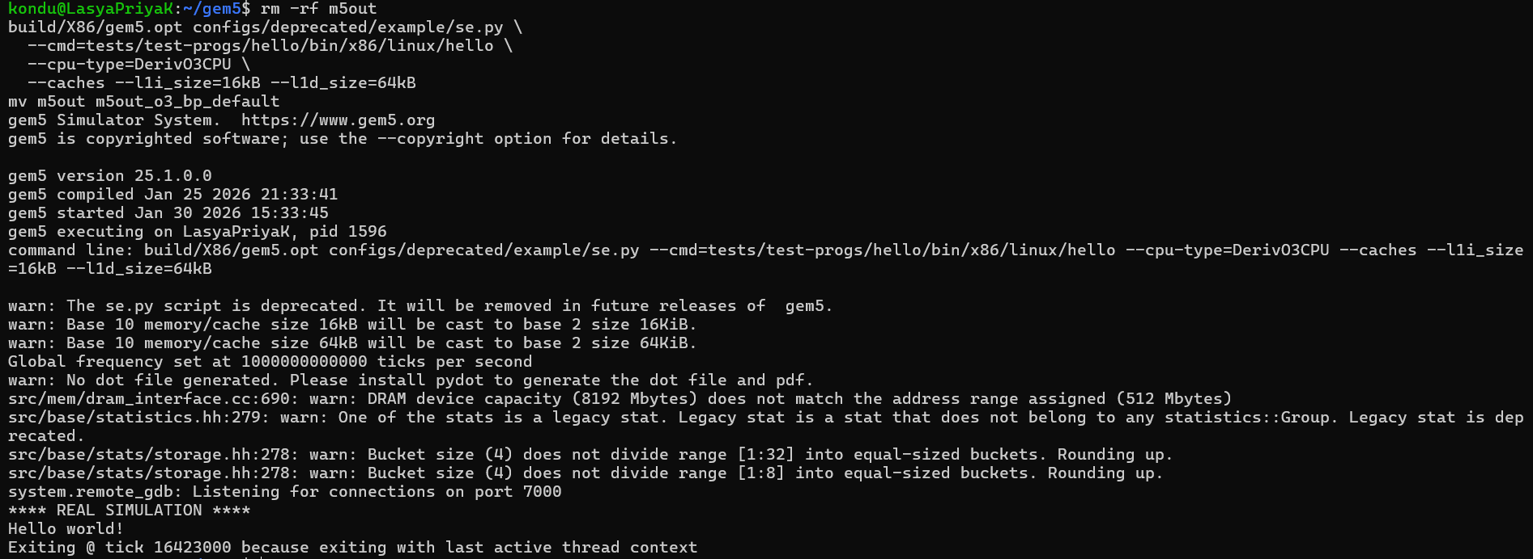
Branch predictor components such as BTB, RAS, and conditional predictors were verified using:
grep -n "branchPred" m5out/config.ini
- “With branch predictor” (default BranchPredictor)
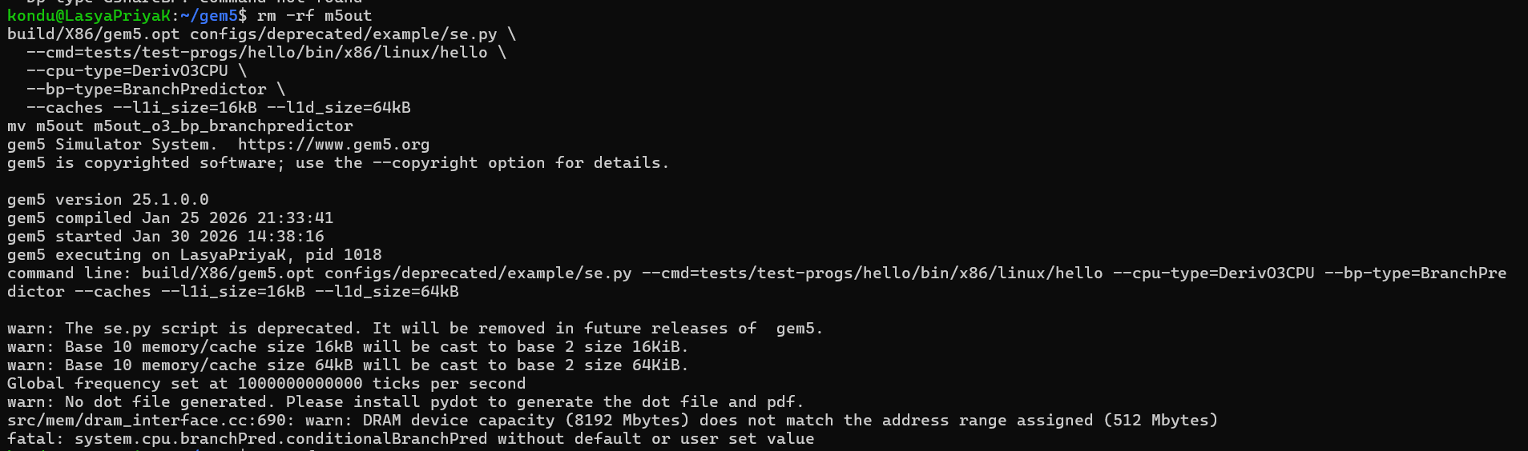
- “Without branch predictor” (disable pred = force always not-taken)
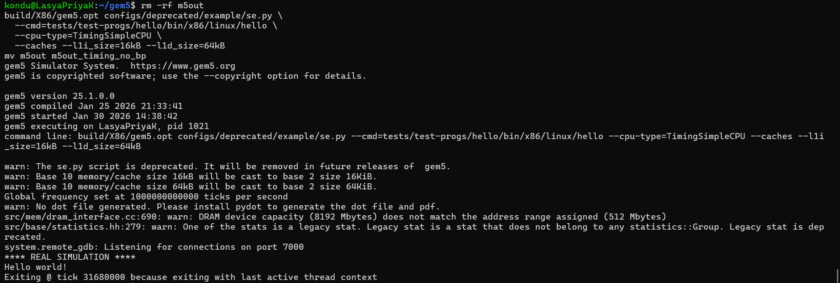
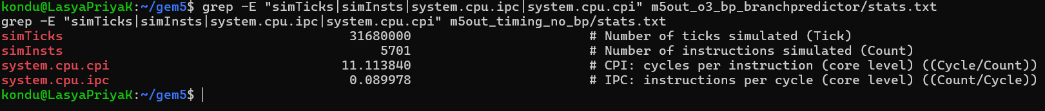
Results Table
Configuration | simTicks | simInsts | CPI | IPC
Default BP | 16,423,000 | 5,701 | 5.761621 | 0.173562

Superscalar Width Experiment (Multiple Issue)
Objective: To study how increasing instruction issue width affects ILP, throughput, and latency.
Configuration
CPU model used:
- DerivO3CPU (out-of-order core)
Two configurations were tested:
- Default width (single-issue style)
- Width = 4 (superscalar configuration)
Width = 1
build/X86/gem5.opt configs/deprecated/example/se.py \
--cmd=tests/test-progs/hello/bin/x86/linux/hello \
--cpu-type=DerivO3CPU \
--caches --l1i_size=16kB --l1d_size=64kB
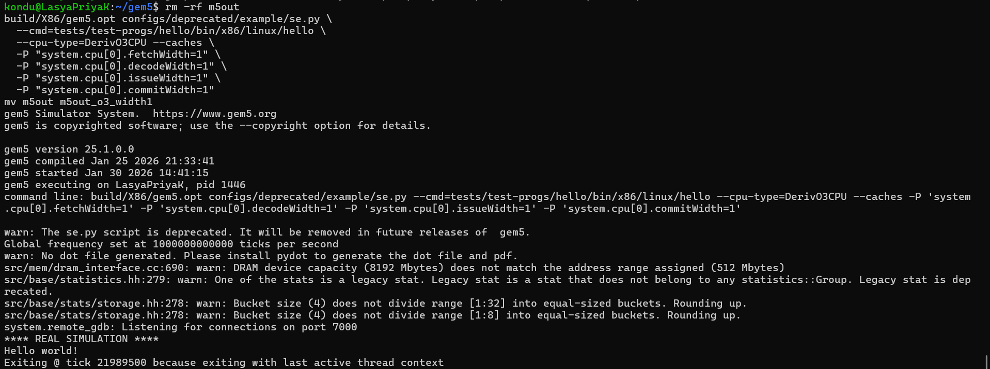
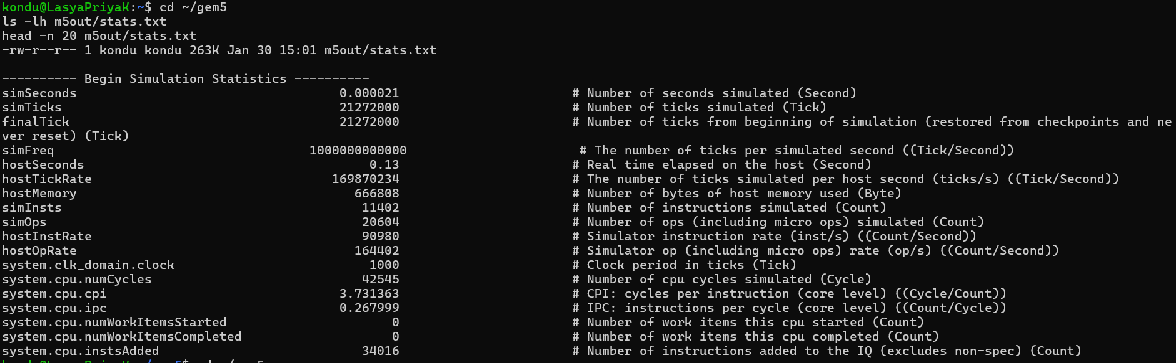
Width = 4
build/X86/gem5.opt configs/deprecated/example/se.py \
--cmd=tests/test-progs/hello/bin/x86/linux/hello \
--cpu-type=DerivO3CPU \
--caches --l1i_size=16kB --l1d_size=64kB \
-P "system.cpu[0].fetchWidth=4" \
-P "system.cpu[0].decodeWidth=4" \
-P "system.cpu[0].issueWidth=4" \
-P "system.cpu[0].commitWidth=4"
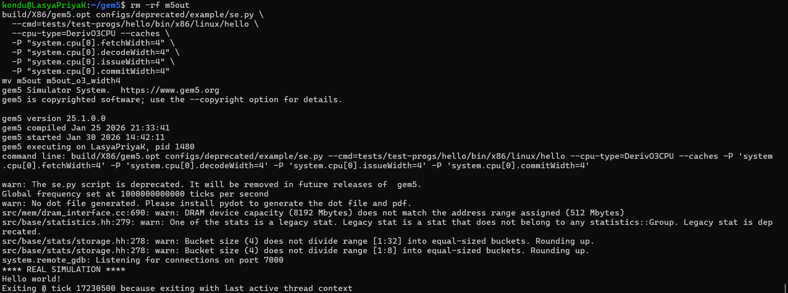
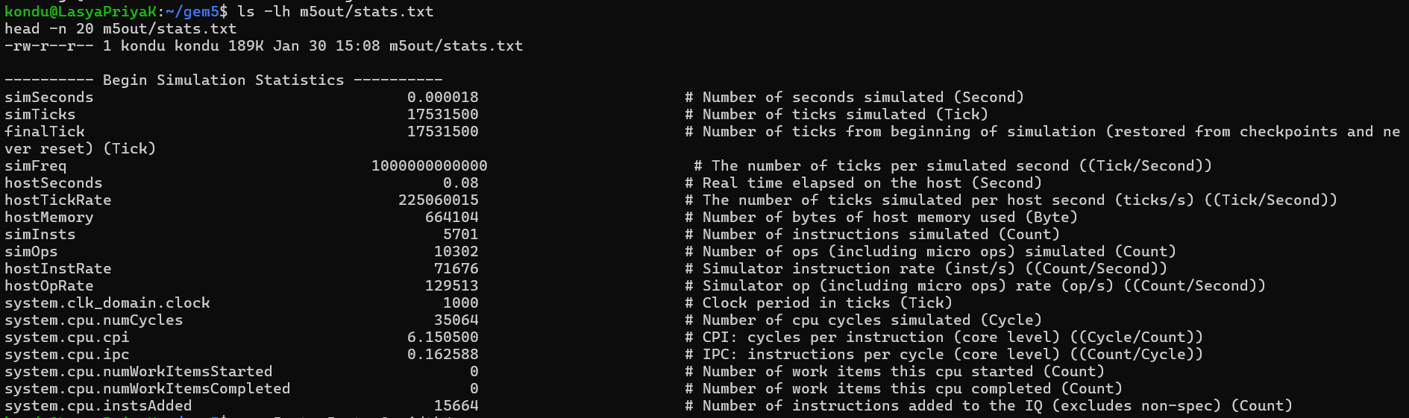
Results
Configuration | simTicks | simInsts | CPI | IPC
O3 Width = 1 | 21,272,000 | 11,402 | 3.731363 | 0.267999
O3 Width = 4 | 17,531,500 | 5,701 | 6.150500 | 0.162588

Simultaneous Multithreading (SMT)
Objective: To observe how running multiple threads on a single core impacts throughput and latency.
Configuration
- CPU: DerivO3CPU
- Threads: 2
- Two identical hello programs executed concurrently
Command Used
build/X86/gem5.opt configs/deprecated/example/se.py \
--cpu-type=DerivO3CPU \
--smt \
--cmd="tests/test-progs/hello/bin/x86/linux/hello;tests/test-progs/hello/bin/x86/linux/hello" \
--caches --l1i_size=16kB --l1d_size=64kB \
-P "system.cpu[0].numThreads=2"
Results
Configuration | simTicks | simInsts | CPI | IPC
O3 SMT (2 threads) | 21,272,000 | 11,402 | 3.731363 | 0.267999

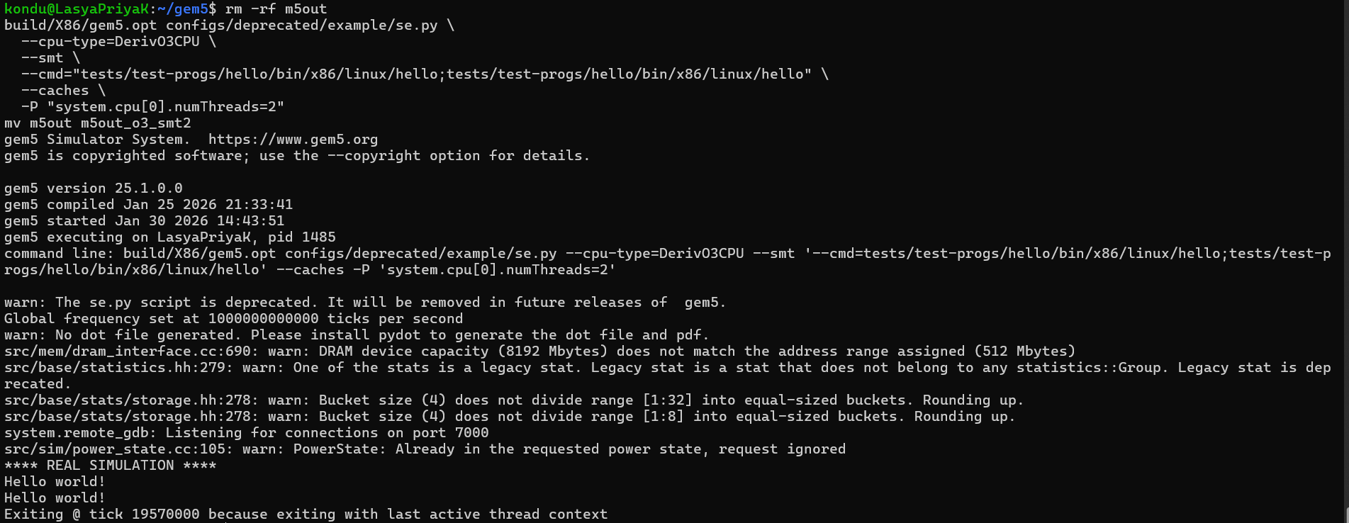
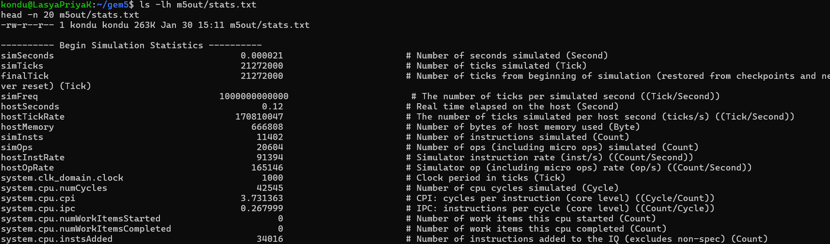
2.6 Notes on Pipeline Visualization (MinorCPU)
For observing pipeline stages such as fetch, decode, execute, memory, and writeback, MinorCPU is more suitable than DerivO3CPU. MinorCPU provides clearer pipeline modeling and supports cycle-level tracing using debug flags.
Pipeline visualization can be enabled using:
build/X86/gem5.opt --debug-help | grep Minor
This experiment can be extended using debug traces to analyze instruction flow across pipeline stages.
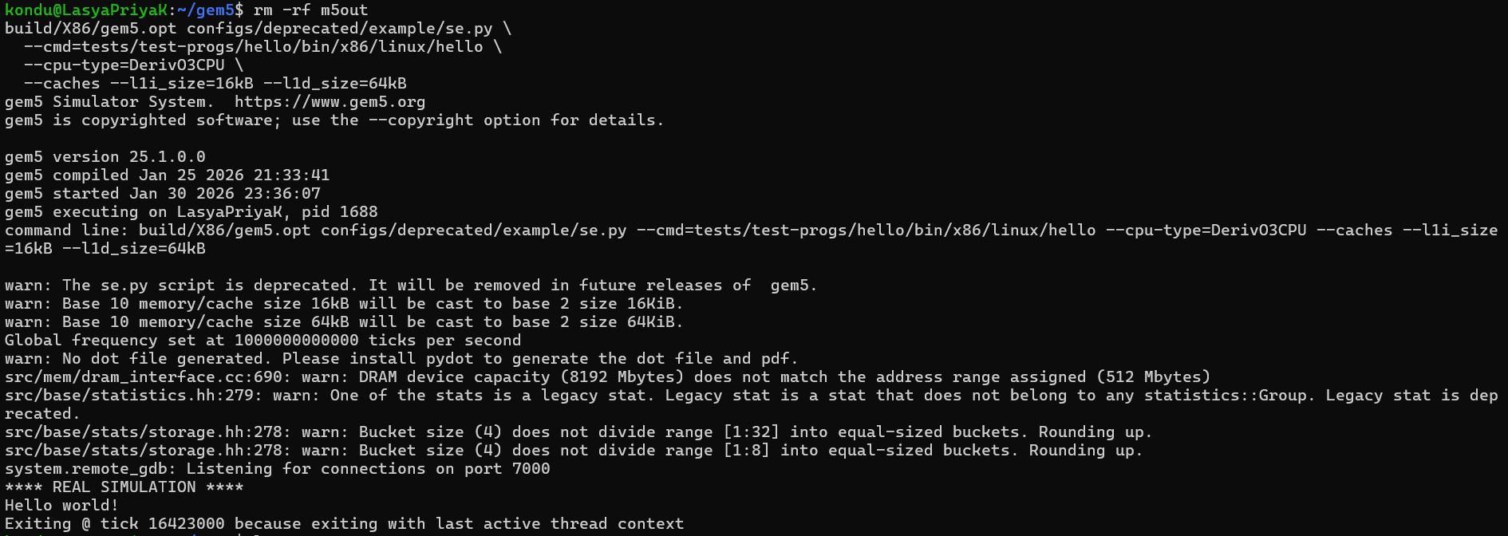
Warnings Observed
The following warnings were observed during simulations:
- se.py deprecation warning
- Cache size casting from kB to KiB
- DRAM capacity mismatch
- Missing pydot for dot file generation
These warnings did not prevent simulation execution or statistics generation.

